Study Programme Coordinator’s Report
The study programme coordinator’s report shall document the quality work carried out at study programme level. In the Universities and University Colleges Act it is stated that the quality system shall ensure and further develop the quality of education (§3-5 (1)). In the Regulations relating to Universities and University Colleges §1-8 (4) it is stated that there must be sufficient information to be able to assess the quality in all study programmes.
At INN we want the study programme coordinator’s report to be a useful tool for reflection on one’s own study programme. We want a learning process based on available data about the study programme.
Quality work at INN follows a simple quality loop where we plan, implement, evaluate and, if necessary, improve before the next cycle. The report shall show how challenges have been followed up with measures, and what has been learned from this.
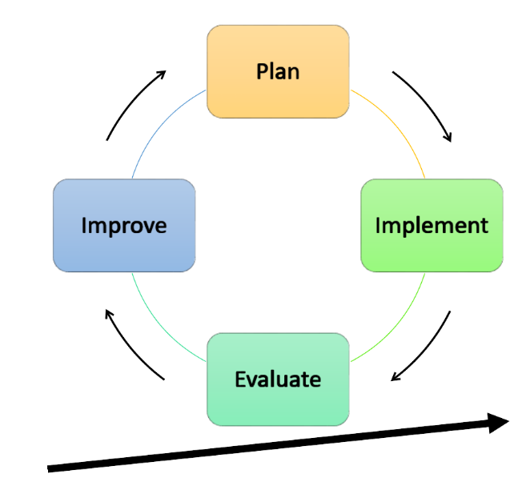
The quality work, and thus also the report, draws its knowledge base from:
- Course evaluations
- Study programme committees
- Conversations with students and/or staff in the team around the study programme
- Surveys such as the Study Start Survey, the Norwegian Student Survey (Studiebarometeret), graduate surveys, other national surveys and our own surveys
- Own experiences

In the Teams room “Study Programme Coordinator – Quality Work” you will find summary reports in PDF format (updated in week 26) showing numerical data that sheds light on the different quality areas. The same reports are available in the STAR data warehouse (Tableau).
Quality work at INN is divided into eight quality areas that summarise important aspects of educational quality. The report template reflects this and has its own fields where we ask you to describe the situation in the study programme under each quality area.
In the “Situation description” box you describe the actual status, with current challenges and/or good experiences related to the quality area:
- What are the most important challenges the study programme faces within this quality area?
- What will you do to meet these challenges (measures)?
- Have you previously tried to address these challenges? How did this work?
- What will you possibly do to improve the measure?
- Is there anything the study programme needs extra support for in order to implement?
- What works well?
- What can we learn from this?
On the front page of the report we ask you to provide a summary of the quality work across the quality areas. This should be concise, but we would like you to be precise about what works well, challenges and needs, an evaluation of last year’s measures, the main measures for the coming year, and long-term development goals.
If the study programme has carried out a periodic evaluation of the programme, the measures in the associated action plan are followed up here.
The completed report should preferably be within 4–6 pages. It is natural that the scope varies according to the type of study programme (one-year study, BA, MA).
All quality areas must be assessed every year, but not all areas need to be treated equally thoroughly. The report shall reflect the actual quality work in the study programme. The faculty, through the dean, can also select certain quality areas as particular focus areas.
We have chosen to include all eight quality areas in the template below, but we recognise that the study programme coordinator does not have equally strong influence over all areas. This applies in particular to K1, since the study programme coordinator does not have personnel responsibility (see also rollebeskrivelsen for studieprogramledere). At the same time, the study programme coordinator experiences the consequences of the overall quality in the academic environment and will need to make this visible. We have therefore chosen to include it, even if you may feel that you cannot yourself implement measures.

Department of Education, INN

Study Programme Coordinator’s Report

Study programme (code and title):
Study programme coordinator (name):
Date:
Summary
This works well
Challenges and needs
Evaluation of last year’s measures
Main measures 2026/2027
Long-term development goals

Quality work in the study programme
Tick off | All | Some | Few
Course Coordinators’ reports received
Class representatives and substitutes elected in all cohorts
Study programme committee (SPU) meetings conducted in both semesters
Comment below if “Some” or “Few” is ticked:

K1 | Academic and pedagogical competence of the academic staff | The academic environments shall maintain a high international level in research and education.
K1 | Current status description:  1. Describe challenges that form the basis for needs and measures  2. Is there anything that works well that you would like to share?  … consult the questions in the introduction to this report template

K2 | Student competence and start of study year | Students shall have a good encounter with the university to lay the foundation for mastery in their studies.
K2 | Current status description:  1. Describe challenges that form the basis for needs and measures  2. Is there anything that works well that you would like to share?  … consult the questions in the introduction to this report template

K3 | Teaching and study activities | Students shall develop good strategies for acquiring new knowledge.
K3 | Situasjonsbeskrivelse:  1. Describe challenges that form the basis for needs and measures  2. Is there anything that works well that you would like to share?  … consult the questions in the introduction to this report template

K4 | Students’ learning outcomes | The university shall offer education with efficient completion and good correspondence between learning outcome descriptions and teaching, supervision and assessment.
K4 | Current status description:  1. Describe challenges that form the basis for needs and measures  2. Is there anything that works well that you would like to share?  … consult the questions in the introduction to this report template

K5 | Students’ learning environment | The university shall have a good learning environment.
K5 | Current status description:  1. Describe challenges that form the basis for needs and measures  2. Is there anything that works well that you would like to share?  … consult the questions in the introduction to this report template

K6 | Interaction between the studies and society and working life | The study programmes shall be relevant for, and stimulate, society and the labour market.
K6 | Current status description:  1. Describe challenges that form the basis for needs and measures  2. Is there anything that works well that you would like to share?  … consult the questions in the introduction to this report template

K7 | Internationalisation | The university’s study programmes shall have an international profile, and place knowledge, experience and values in an international context.
K7 | Current status description:  1. Describe challenges that form the basis for needs and measures  2. Is there anything that works well that you would like to share?  … consult the questions in the introduction to this report template

K8 | Development and management of the study programmes | The study programmes shall be managed effectively and ensure continuous improvement.
K8 | Current status description:  1. Describe challenges that form the basis for needs and measures  2. Is there anything that works well that you would like to share?  … consult the questions in the introduction to this report template

If the Study Programme has carried out a periodic evaluation and has measures in the action plan that are to be implemented in the long term, these are entered here together with other relevant development goals..

